GOOGLE MY BUSINESS PROFILE

INTRODUCTION

1.1 Creating a Google My Business profile is a crucial step for local businesses to enhance their online presence. Here's an overview of the process:

1. Sign In or Sign Up:

- Visit the Google My Business website.

- Sign in with your Google account or create one if you don't have it.

2. Add Your Business:

- Enter your business name.

- Choose your business category.

- Add your business location (if applicable).

3. Verify Your Business:

- Google will send a postcard with a verification code to your business address (typically takes 1-2 weeks).

4. Complete Your Profile:

- Add essential details such as your business hours, website, phone number, and a description.

5. Add Photos and Videos:

- Upload high-quality images of your business, including the logo, interior, exterior, and products/services.

PURPOSE

The purpose of opening a gym can vary but some common reasons include promoting physical fitness providing a space for people to exercise improving health and well ;being and creating a business opportunity gyms offer a range of equipment and facilities to help lndividuals achieve their fitness goals and lead a healthier lifestyle.

Empathy Map



BRAIN STROM

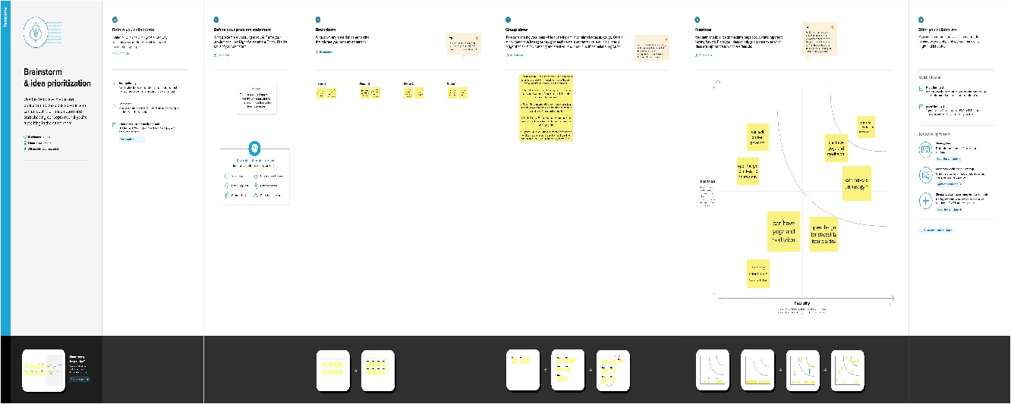

RESULT

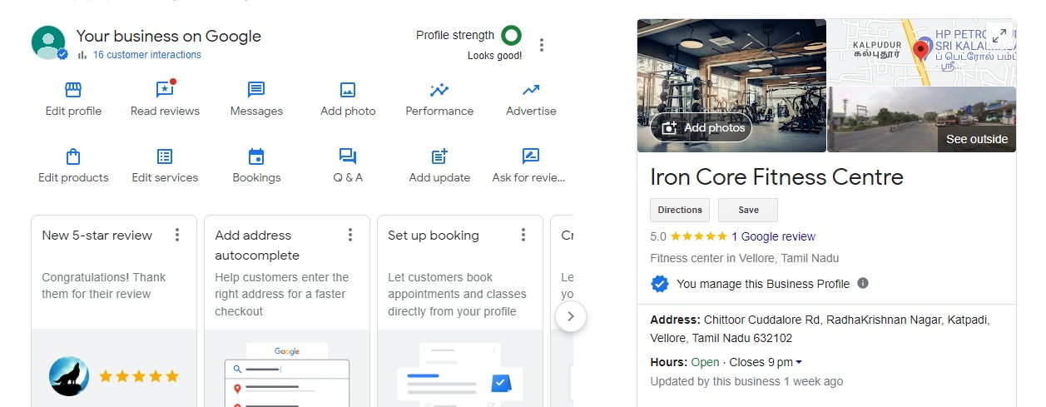

ADVANTAGES

. Improved physical fitness: Regular exercise at the gym can help you build strength, endurance, and flexibility.

2. Weight management: Gym workouts can assist in weight loss or maintenance by burning calories and increasing metabolism.

3. Better mental health: Exercise releases endorphins, which can reduce stress and improve mood.

4. Disease prevention: Regular physical activity can lower the risk of chronic conditions like heart disease, diabetes, and obesity.

5. Increased energy: Exercise can boost your energy levels and overall stamina.

6. Social interaction: Gyms provide opportunities to meet like-minded people and build a supportive fitness community.

7. Variety of equipment: Gyms offer a range of equipment to target different muscle groups and fitness goals.

8. Professional guidance: Personal trainers can offer expert advice and customized workout plans.

9. Convenience: Many gyms have flexible hours and locations, making it easier to fit exercise into your schedule.

10. Improved self-esteem: Achieving fitness goals can boost your self-confidence and body image.

DISADVANTAGES

1. Cost: Gym memberships and personal training can be expensive, which may not be affordable for everyone.

2. Time commitment: Frequent gym visits require time, and some people may struggle to fit it into their busy schedules.

3. Crowds: Popular gyms can be crowded, especially during peak hours, making it challenging to access equipment.

4. Intimidation: Some individuals may feel self-conscious or intimidated in a gym setting, especially if they are new to exercise.

5. Hygiene concerns: Gyms can be breeding grounds for germs, so it's important to practice good hygiene and sanitation.

APPLICATIONS

1. Physical Fitness Gym:

- Weight training: Gyms are commonly used for strength training and muscle building.

- Cardiovascular workouts: Treadmills, stationary bikes, and elliptical machines are used for aerobic exercises.

- Group fitness classes: Gyms offer classes like yoga, spin, and Zumba for social and structured workouts.

- Sports-specific training: Athletes use gyms to enhance their performance for various sports.

- Rehabilitation: Gyms often have equipment and trainers for physical therapy and rehabilitation.

CONCLUSION

Opening a gym can be a promising venture, but it's important to carefully consider the following key points before proceeding:

1. Market Research: Conduct thorough market research to assess the demand for a gym in your area. Identify your target audience and competitors.

2. Location: Choose a strategic location that is accessible and visible to your target demographic.

3. Business Plan: Develop a comprehensive business plan that outlines your gym's offerings, pricing, marketing strategy, and financial projections.

4. Licensing and Regulations: Familiarize yourself with local health and safety regulations, and ensure you have the necessary permits and licenses to operate.

5. Equipment and Facilities: Invest in quality fitness equipment and create a well-designed gym space that caters to various workout preferences.